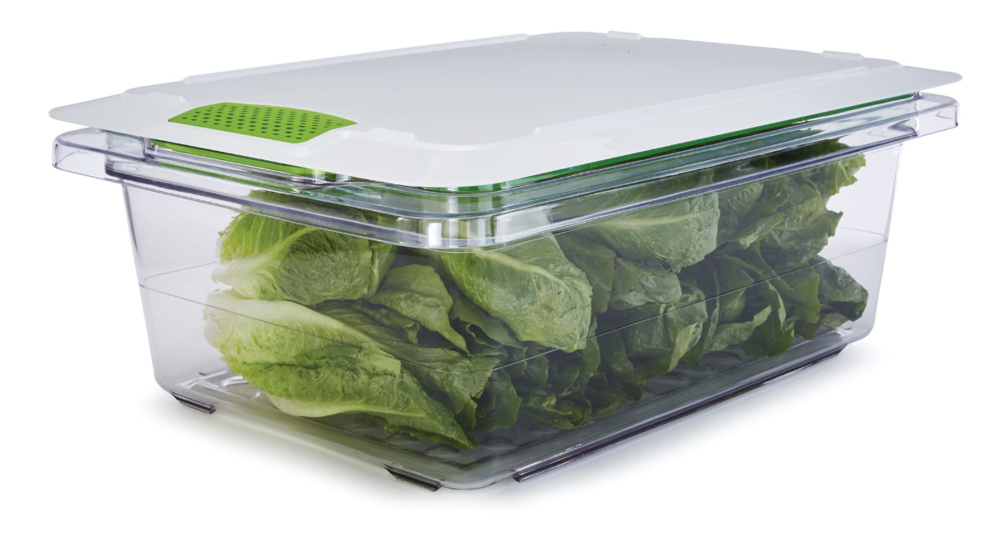

Rubbermaid® Commercial Products Freshworks™ Produce Saver

The RCP Freshworks™ Produce Saver keeps produce fresher longer*. The Produce Saver regulates the flow of oxygen and ethylene, creating the optimal environment to store fruits and vegetables. By allowing produce to “breathe”, they stay at their peak freshness for a longer period of time, reducing the amount of food thrown away due to spoilage. The containers are made of heavy duty, commercial grade polycarbonate and are dishwasher safe. The filter has a unique long lasting silicone coating, meaning it never needs to be changed or replaced.

KEY BENEFITS:
- Produce Life Extension: Keeps Produce Fresher Longer*
  - Produce preserving technology works with a variety of the most common types of produce stored in traditional food boxes, results vary based on produce and use*
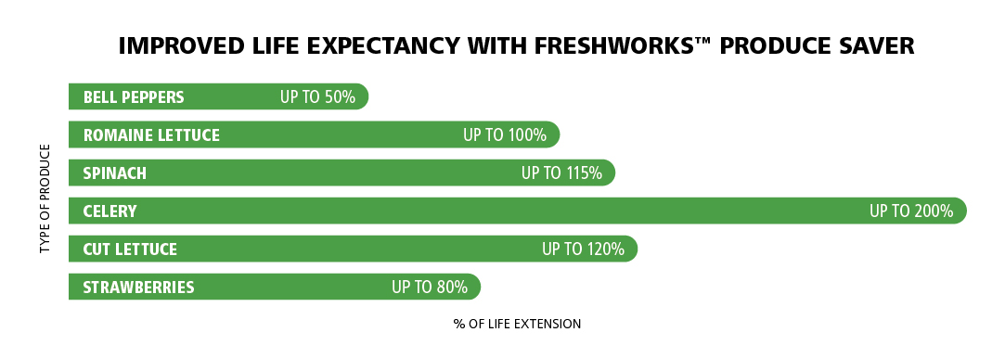
- Patented Filter: Patented filter regulates the flow of oxygen and ethylene, and never needs to be changed or replaced
- Built-In Drain Tray: Unique drain tray design elevates produce from residual moisture to promote air flow
- Air Tight Lid: Lids are easy to open and close, and helps to create the optimal environment within the container
- Commercial Dishwasher Safe: Heavy duty construction can withstand commercial dishwashing
- NSF Approved: Containers and lids are certified under NSF Std. 2 for food storage

For more information about the Freshworks™ Produce Saver or to find a Rubbermaid Commercial Products distributor or wholesaler, please visit www.rubbermaidcommercial.com.

For more information, please contact Jim Smith at RCP: Jim.Smith@newellco.com / (704) 728-9376

